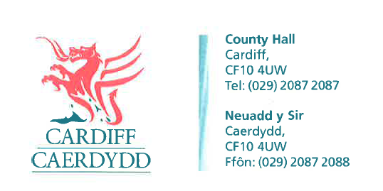
FOI Response Document

FOI 06597

Thank you for your request under the Freedom of Information Act 2000 about Zero Hours contracts received on 31st March 2015.
Your request asked for
Q1 How many employees has Cardiff City Council employed on Zero Hours Contracts since April 2011?

RESPONSE: : The City of Cardiff Council do not employ staff on zero hours contracts.
Our understanding of zero hours contracts is that staff are assigned to one organisation, and they are not allowed to be employed elsewhere

Q2 How many employees does Cardiff City Council currently employ on Zero Hours Contracts..
RESPONSE : We do operate casual contracts, where staff can accept or decline work, but they can also work for other organisations with no restrictions.

For information, we currently have 2,700 casual workers on our payroll.
If you have any queries or concerns, please do not hesitate to contact us.
Please remember to quote the reference number above in any future communications.
:

